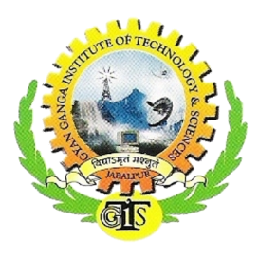

P.O. Tilwara Ghat, Near Bargi Hills, Jabalpur-482003

**Glimpse** V1 I1 Computer Science Department August 2013

**Our Vision and Aim**

* To be a leading center of technical education in computer science in India.
* To produce future citizens of the country to meet the upcoming global challenges.
* Empower students with the state of art facilities and knowledge for the welfare of the society and the nation.
* Prepare students as per the ever changing need of the industry.
* To inculcate ethical values in the minds of emerging engineers.

*Like every year students of GGITS got selected in Multi-National Companies. Know more about them in coming pages…*

●●●

**From the editor's desk:**

The current issue covers the news concerning Department of Computer Science & Engineering, such as various cultural and technical events, lecture series, academic collaborations, campus updates, laurels won both by students and faculty members. It also highlights about upcoming events along with our plan for the departmental activities

●●●

**In this Issue:**

* Academic Activities
* Campus News
* Student Achievements
* Departmental Activities
* Euphonus 2013

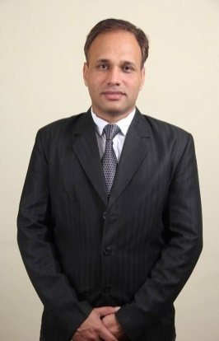

*“It gives me immense pleasure to announce launch of department Newsletter, Glimpse which is going to be published annually and is apt for facilitating information about the activities, achievements and upcoming events of the department of Computer Science & Engineering across the college. Please enjoy the many departmental highlights of the academic year.”*

**Mr. Ashok Verma**

**Professor and Head of Computer Science Department**

**Academic Activities**

* Training by ESQUARE for CSE & IT Training was organised for VI Sem. (2010-14)
* Batch students of CSE & IT students by E-SQUARE on "SQL SERVER 2005/2008" from 7th January 2013 to 16th January 2013. Total of 110 students attended this training. Aman Raikwar, Nazneen Jahan, Sanjay Dubey, Abhijeet Maity, Meghna, Tarik Khan, Amit Srivastava and Nandini Patel were the trainers.
* International Conference on Emerging Materials Technology 2013 (ICEMT 2013)

International Conference on Emerging Materials Technology 2013 (ICEMT 2013) was organized from 8th- 10th April 2013. Highlights of the conference were exhibition booths, workshops and Guest lectures from Foreign Delegates and Corporate from Industry. The main topics for the workshops were the following:

* Principles and Methods of Composites Manufacturing - Resource Person- Dr. N.G. Nair, Former Dept Head, IIT Chennai & Mr. T.Ramamurthy.
* FRP Composite Manufacturing & Application to Infra-Structure-Resource Person- Dr. Hota Ganga Rao, Ph. D., P.E. Fellow ASCE,(USA) and Mr. David Dittenberg (USA).
* Advances in Composites in Auto Industry-Resource Person-Mr. Nachiket Thakur ,Head of Innovation Center and GM Product Design & Development at Mahindra Composites, Pune.
* Training on Advanced Java & Struts under Oracle Workforce Development Program
* As part of OWDP Program 60 hrs. training was organized for 5th & 7th Semester Students of CSE & IT at Centralized Lab, GGITS. Course material was in the form ekits provided by Oracle University. Students received e-certificate on successful completion of training program

**Campus News**

*Many Industry giants visited campus for placements and selected all the deserving students.*

* 15 students in Zensar Technologies Ltd.
* 07 students in Hexaware Technologies Ltd.
* 03 students in AMDOCS
* 05 students in Unisys Ltd.
* 04 students in Persistent Technologies
* 01 student in Sigma Soft
* 01 students in Ingram Micro





Student’s Achievements

* *Chancellors Scholarship 2012-13*

* Yashasvini Sharma, CSE Chancellors Scholarship in Academic Year 2012-13.
* *Current Semester Toppers – CSE*

* Sushmita Jain, 7th Sem, Scored-82.40%
* Jalpreet KaurSaluja, 5thSem, Scored- SGPA: 8.75
* HarshitaAgrawal, 3rd semester, Scored - SGPA: 8.27

Departmental Activities

**Quizopolis**

It was an intra-college online-quiz competition organized by the department of Computer Science and Engineering of GGITS, Jabalpur. The event was held on 5th &6th September, 2012. The Quiz was based on objective type questions covering topics like Sports, History, Current affairs, Technical Skills & General awareness .First, second and third prizes were HTC MOBILE, FUNBOOK and CAMERA respectively. Participation certificates were also given. Top 50 scorers were given PEN DRIVE each.

**Epistemology**

It was a technical event conducted by Department of CSE & IT in Collaboration with EMC2 Presents “Epistemology”. A Technical Event on Cloud and Big Data On 12th September .Technology is evolving with every passing day. It has changed the way we learn, socialize, shop, bank etc. To keep up the pace with changing technology one needs to keep themselves updated about the future technologies along with the existing one. EPISTEMOLOGY is such an effort to update you with the latest technology in IT industry. Here experts share their view on the new technology as well as it’s a good platform for students to showcase their talent and also win a lot of prizes along with. There were different competitions organized like Online Quiz, Paper Presentation & Poster Presentation. The theme of all the competitions was based on Cloud Computing and Information Storage. Prizes were :1st Prize :- 1 TB NAS Box, 2nd Prize:- 1 ISM Book, 1 EMC Branded T-shirt and 1 8GB USB Drive ,3rd Prize:- 1 EMC Branded T-shirt and 1 8GB USB Drive.

Tech Fest-Euphonus 2k13

**Euphonus 2013**

Like every year Euphonus , Techfest of GGITS was held on 11th & 12 th April. This time also the event witnessed lot of activities and participation. There were around 24 activities like Lan gaming, Temple Run, Nataraj, Business plan, Code edge, Couple Cricket, Rhodies, Master Chef, RJ Hunt, Photography, Tug of war, Music, Fruit Ninja, PushpRangoli, Robomania, Art & Craft , Fashion Show etc. The major attraction was Profnite in which famous play back singer Mr. Neeraj Shridhar gave live performance in the amphitheatre of GGITS. Department organized two events Nataraj and Fashion Band. The entire event was planned, organized and managed by student coordinators under the guidance of faculty.

The Euphonus Website-

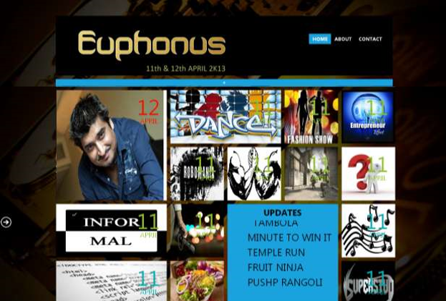

# Profnite

# *The major attraction was Profnite in which famous play back singer Mr. Neeraj Shridhar gave live performance in the amphitheatre of GGITS*



Designed By- Shikhar Shrivastava

7th Semester, CSE Department, GGITS.